**How to enable the F2 Functionality for Epic on your Mac**

**(**also can enable Alt key**)**

**Author**: Ben Orwoll, MD – [orwollb@ohsu.edu](mailto:orwollb@ohsu.edu)

**Disclaimer**: This workflow is the work of the author and is not officially supported by Epic Systems or by Oregon Health & Science University

**System Requirements:**

* Mac Computer running at least Mac OS Version 10.11 (El Capitan)
* Local Administrator account access
* Working installation of Citrix Receiver for Mac
  + ie. You can already run Epic
  + this guide is not intended for users of the in-browser (Citrix Lite) version of Citrix

**Step 1**: Install the necessary Software (Karabiner Elements - <https://pqrs.org/osx/karabiner/>)

1. download the most recent version of the installer
   1. click the “Download Karabiner-Elements” button
   2. open the disk image file that is downloaded
2. Run the installer package



1. Follow the prompts and complete the default installation
2. Find and open the “Karabiner-Elements” app
   1. Will be located in the Applications folder
   2. Can also do spotlight  search for Karabiner-Elements
3. **Carefully** read and follow directions during keyboard identification process
   1. 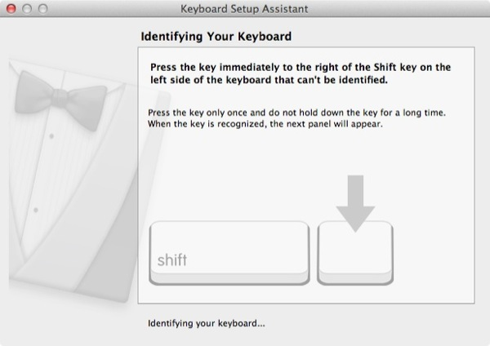
4. You should now see something that looks like this:
   1. 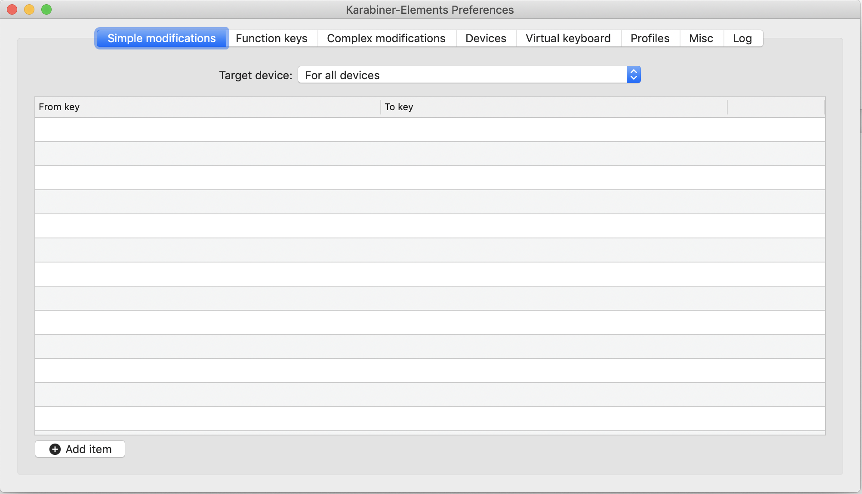
   2. Or this:  
      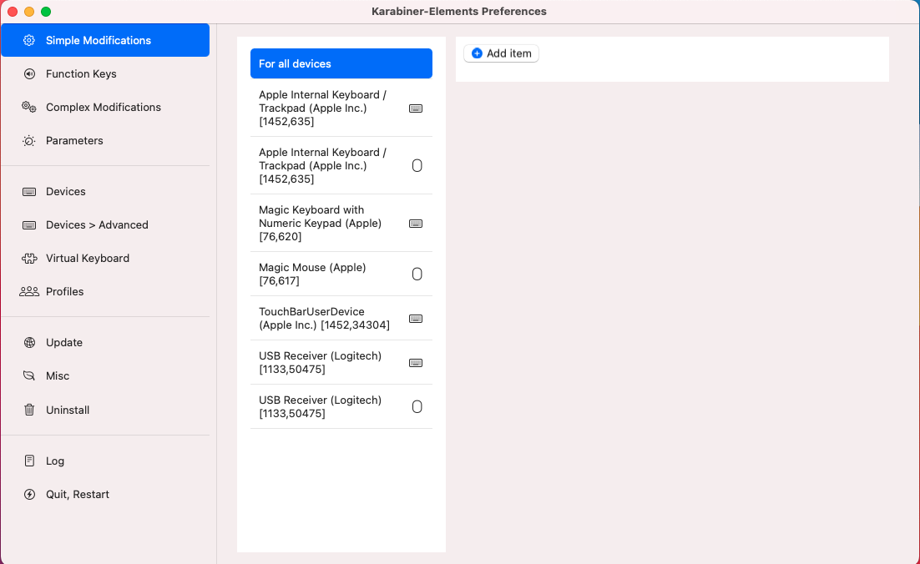
5. You will need to download both of the following files (if it just comes up as text in your browser you can go to File>Save As>

If you are using Chrome/Firefox/Brave/Edge: save as will just work

If you are using **Safari:** when you save you must change the save option from “web archive” to “page source” 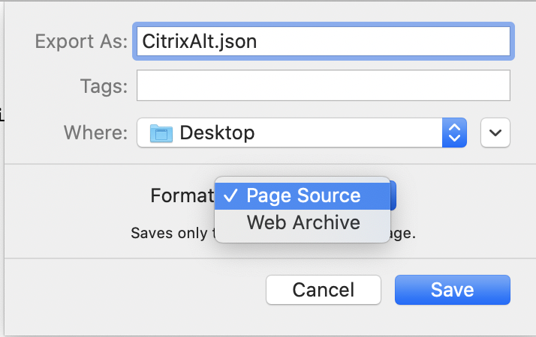

* + - Additionally ***make sure*** that the file name ends in “.json” not “.json.txt”
    - If the computer asks if you want to add a “.txt” to the file when you save it **just say NO**

**File Links:**

* 1. **For users of Mac computers with *physical* F(function) keys (most people)**
     1. [JSON Files (regular)](https://github.com/benhmin/karabiner-mac-citrix/blob/main/Complex%20Modifications/Regular/JSON%20Files%20(regular).zip?raw=true) (link: [https://github.com/benhmin/karabiner-mac-citrix/blob/main/Complex Modifications/Regular/JSON Files (regular).zip?raw=true](https://github.com/benhmin/karabiner-mac-citrix/blob/main/Complex%20Modifications/Regular/JSON%20Files%20(regular).zip?raw=true))
  2. **Only for users with** [**Touch-Bar**](https://support.apple.com/en-us/HT207055) **enabled Macs**
     1. [JSON Files (touchbar)](https://github.com/benhmin/karabiner-mac-citrix/blob/main/Complex%20Modifications/Touchbar/JSON%20Files%20(touchbar).zip?raw=true) (link: [https://github.com/benhmin/karabiner-mac-citrix/blob/main/Complex Modifications/Touchbar/JSON Files (touchbar).zip?raw=true](https://github.com/benhmin/karabiner-mac-citrix/blob/main/Complex%20Modifications/Touchbar/JSON%20Files%20(touchbar).zip?raw=true))

1. The 2 files now need to be copied into a specific folder on your computer:
   1. Using the finder , go to the **Go** menu and choose “Go to folder”
   2. In the dialog box the opens, paste the following text:

~/.config/karabiner/assets/complex_modifications/

* 1. A folder window will open up (it will likely be empty)
  2. Drag and drop both of the files from your downloads folder (or wherever you saved them) into the folder that opens (the complex modifications folder)

1. OK! You’re now ready to import those scripts (they are called “complex modifications” in karabiner).
   1. Open Karabiner-Elements
      1. You can find it in the applications folder - OR
      2. Use spotlight (CMD-Space or click the  magnifying glass in the upper right of your screen) and search for “Karabiner” - OR
      3. Click the little karabiner icon ( or  depending on the version) in the toolbar on the upper right of your screen (near Wifi, Bluetooth, clock, etc)
         1. Choose “preferences”
   2. You will see this screen:   
      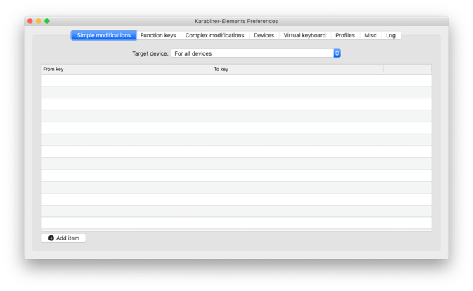or 
   3. Click “complex modifications”
      1. Then click  “add rule” in the lower left
   4. You should see the two rules that we copied to the complex modifications folder in a list that appears: 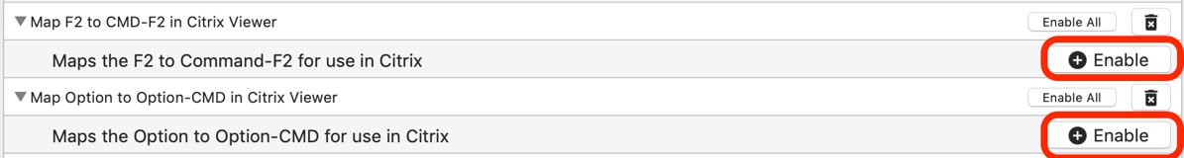
      1. Click enable on the “F2 to Command-F2 for use in Citrix” rule
      2. Once that is done you can optionally click add rule again and add the option to option-CMD rule as well
   5. When you are done you should see a screen that looks like this, with the two rules added:
      1. 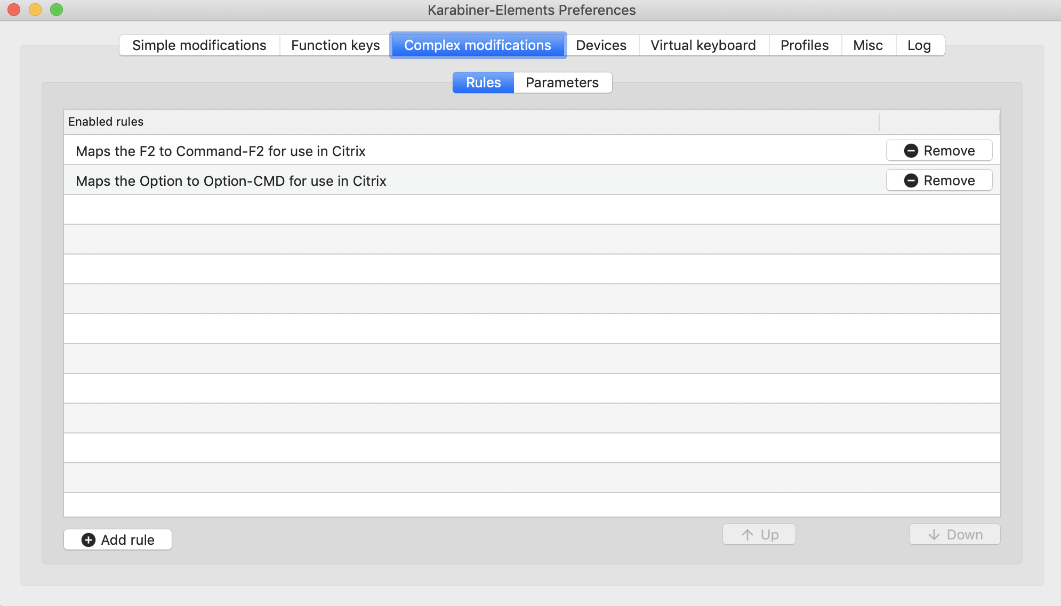
2. ***ONLY*** IF YOU HAVE A TOUCHAR ENABLED MAC!!! Do the following:

***If you do not have a touchbar enabled mac skip to step 11***

* 1. Open System Preferences by clicking on the  in the dock or by choosing System Preferences from the Apple menu in the upper left corner of the screen
  2. Open the “Keyboard” section
     1. Go to the shortcuts tab
     2. Find the function keys section and click the “+” button
     3. 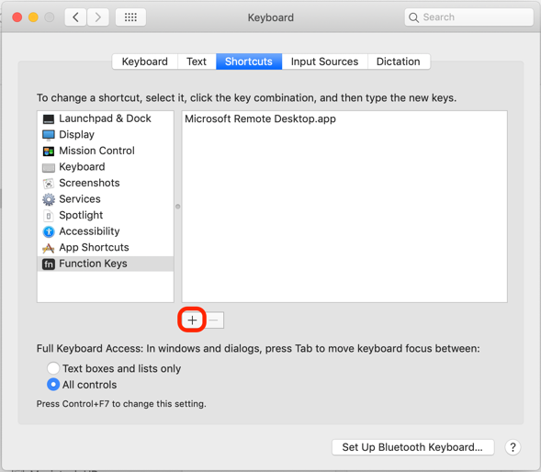
     4. Now, when a window pops up it will ask you to select an application:
        1. Press the following keys together – **CMD-shift-G**
        2. Then copy and paste the following into where it says “go to the folder”

/Library/Application Support/Citrix Receiver/Citrix Viewer.app

* + - 1. Click “Go”
      2. You should be able to now click “Add” and Citrix Viewer application should appear in the list in the box on the right.

1. We’re almost there!
   1. You now need to click the “function keys” button next to “complex modifications”
   2. Make one modification:
      1. Change the f2 physical key row to f2 in the to_key row
      2. Should go from something like this: 
      3. To something like this: 
      4. Don’t change any of the other keys! (unless you want to)
   3. Ok you’re done with Karabiner-Elements for now, you can close the window
      1. The little icon  should stay in your toolbar up on the right, that indicates the program is still running and doing its job
2. Ok last step, we now have to change one thing in the **citrix viewer** application
   1. Go ahead and open Epic however you normally do
   2. Once you have it open, go up to the “Citrix Viewer” menu and choose “preferences”
      1. 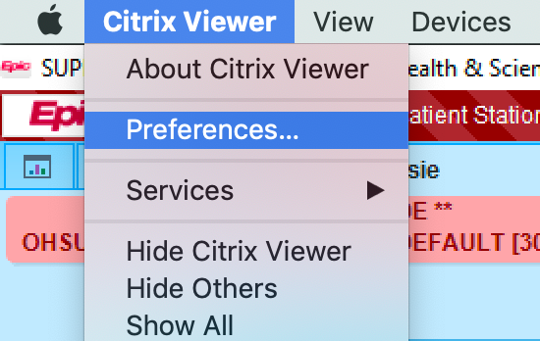
   3. In the preferences window that opens: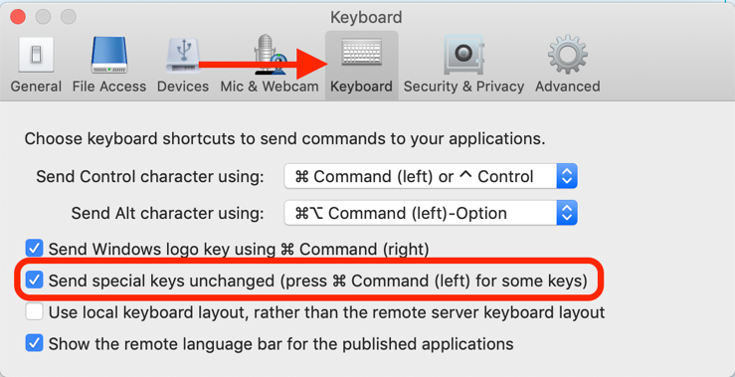
      1. Go to the Keyboard section
      2. Make sure that the “send special keys unchanged” box is **CHECKED**
   4. Now you must fully *quit* citrix viewer
      1. Got to citrix viewer menu and choose “Quit Citrix Viewer”
         1. Choose “Disconnect” at the next prompt, if shown
      2. Do the same with any other open instances of epic.
3. You should be ready to go!
   1. Try to open Epic again and see if your F2 key works to advance through *** wildcards
   2. Shift-F2 also should work to go *backwards* through wildcards
   3. If you enabled the option to cmd-option complex modification you should also be able to use the Option ⌥ key as the Alt key while using epic
   4. **** Keep in mind, this modification should only affect you while using Citrix. The rest of the time the f2 key will behave like normally (increase brightness) ****

Please contact me with questions – I would be willing to arrange potential demos to groups